Unit 5 – Lesson 1. How Web App Works – Server Side vs. Client Side, HTTP Basics
Aim:
- What is HTTP?
- What is server side and what is client side?

Objectives: After the lesson, students will be able to:
- Obtain basic understanding on how web application works
- Obtain understanding on server side program vs. client side program

CLASS PROCEDURE:

Do Now: Discuss with your partner and search online to find the definitions for the following terms:

- TCP / IP

- HTTP

Class Discussion / Presentation:

- What is a server and what is a client?

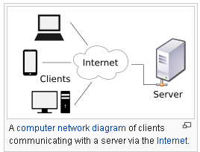

- What is a URL?

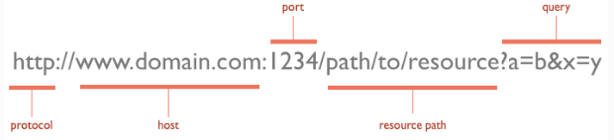

- HTTP request / response pair:

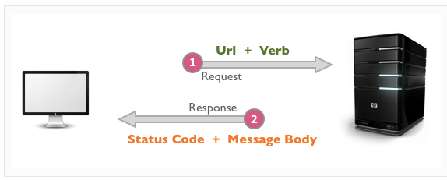

- What does the request or response message look like?
The HTTP specification states that a request or response message has the following generic structure:
message = <start-line>
*(<message-header>)
CRLF
[<message-body>]

<start-line> = Request-Line | Status-Line
<message-header> = Field-Name ':' Field-Value

It's mandatory to place a new line between the message headers and body. The message can contain one or more headers, of which are broadly classified into:
- general headers: that are applicable for both request and response messages.
- request specific headers.
- response specific headers.
- entity headers.
The message body may contain the complete entity data, or it may be piecemeal if the chunked encoding (Transfer-Encoding: chunked) is used. All HTTP/1.1 clients are required to accept the Transfer-Encoding header.

- When you search online, sometimes you get error messages. What are the most common errors you see when a webpage no longer exists?

- Common Client side errors:

404 Not Found, which I think everyone will identify with. 404 indicates that the resource is invalid and does not exist on the server.
- 401 Unauthorized: request requires authentication. The client can repeat the request with the Authorization header. If the client already included the Authorization header, then the credentials were wrong.
- 403 Forbidden: server has denied access to the resource.
- 405 Method Not Allowed: invalid HTTP verb used in the request line, or the server does not support that verb.
- 409 Conflict: the server could not complete the request because the client is trying to modify a resource that is newer than the client's timestamp. Conflicts arise mostly for PUT requests during collaborative edits on a resource.
- Common Server side errors:

- The most commonly used error code is 500 Internal Server Error.
- 501 Not Implemented: the server does not yet support the requested functionality.
- 503 Service Unavailable: this could happen if an internal system on the server has failed or the server is overloaded. Typically, the server won't even respond and the request will timeout.

Pair – sharing Activity:

Read the online article about HTTP https://code.tutsplus.com/tutorials/http-the-protocol-every-web-developer-must-know-part-1--net-31177

Discuss with your partner and answer the following questions:

- What are some of the URLs verbs?

- What are some of the URLs status codes?

- What is the HTTP general request message format?

- What is the general HTTP response message format?

- List a couple of tools to view HTTP traffic.

- Use your own words to explain the HTTP basics and the major benefits of using HTTP.

